**Muhammad Abdullah**

**SE(6A) | 19F-0916**

Web Engineering Course

Assignment 6: React

REACT Counter

App.js Code:

import React, { useState } from "react";

import "./App.css";

function getFavicon() {

  return document.getElementById("favicon");

}

const App = () => {

const [count, setcount] = useState(0)

const [count2, setcount2] = useState(0)

const favicon = getFavicon();

const Increment = () => {

  if(count > 8)

  {

    favicon.href = "red.ico";

  }

  else{

  setcount(count + 1)

  favicon.href = "gr.ico";

  }

}

const Decrement = () => {

  if(count < 1)

  {

    favicon.href = "red.ico";

  }

  else

  {

    setcount(count - 1)

    favicon.href = "gr.ico";

  }

}

const Reset = () => {

    setcount(0);

    favicon.href = "favicon.ico";

  }

return (

    <div style={{

    display: 'flex',

    flexDirection: 'column',

    alignItems: 'center',

    justifyContent: 'center',

    fontSize: '300%',

    position: 'absolute',

    width: '100%',

    height: '100%',

    top: '-15%',

    }}>

    Count Changer For FavIcon

    <div style={{

        fontSize: '120%',

        position: 'relative',

        top: '10vh',

    }}>

    {count2}{count}

    </div>

    <div className="buttons">

        <button style={{

        fontSize: '60%',

        position: 'relative',

        top: '20vh',

        marginRight: '5px',

        borderRadius: '8%',

        backgroundColor:'green',

        padding: '15px 32px',

        color: 'white',

        }}

        onClick={Decrement}>-</button>

        <button style={{

        fontSize: '60%',

        position: 'relative',

        top: '20vh',

        marginLeft: '5px',

        backgroundColor: 'gray',

        borderRadius: '8%',

        color: 'white',

        }}

        onClick={Reset}>Reset</button>

        <button style={{

        fontSize: '60%',

        position: 'relative',

        top: '20vh',

        marginLeft: '5px',

        borderRadius: '8%',

        padding: '15px 32px',

        backgroundColor:'red',

        color: 'white',

        }}

        onClick={Increment}>+</button>

    </div>

    </div>

)

}

export default App

Downloaded gr and red ico files for showing States

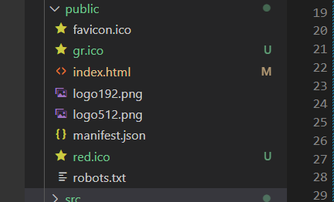

Screenshot of Normal State:

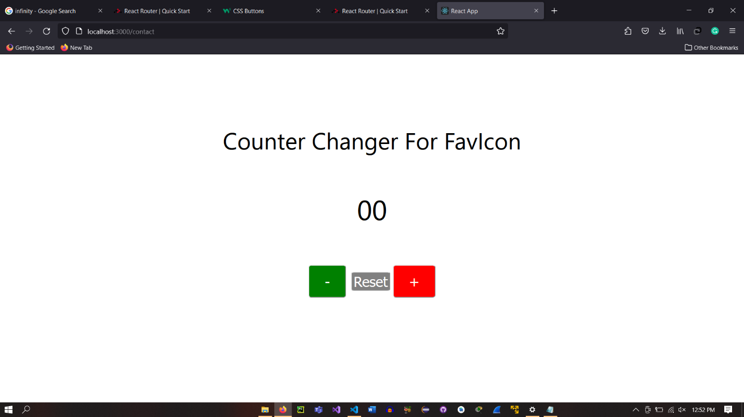

Screenshot of Success State:

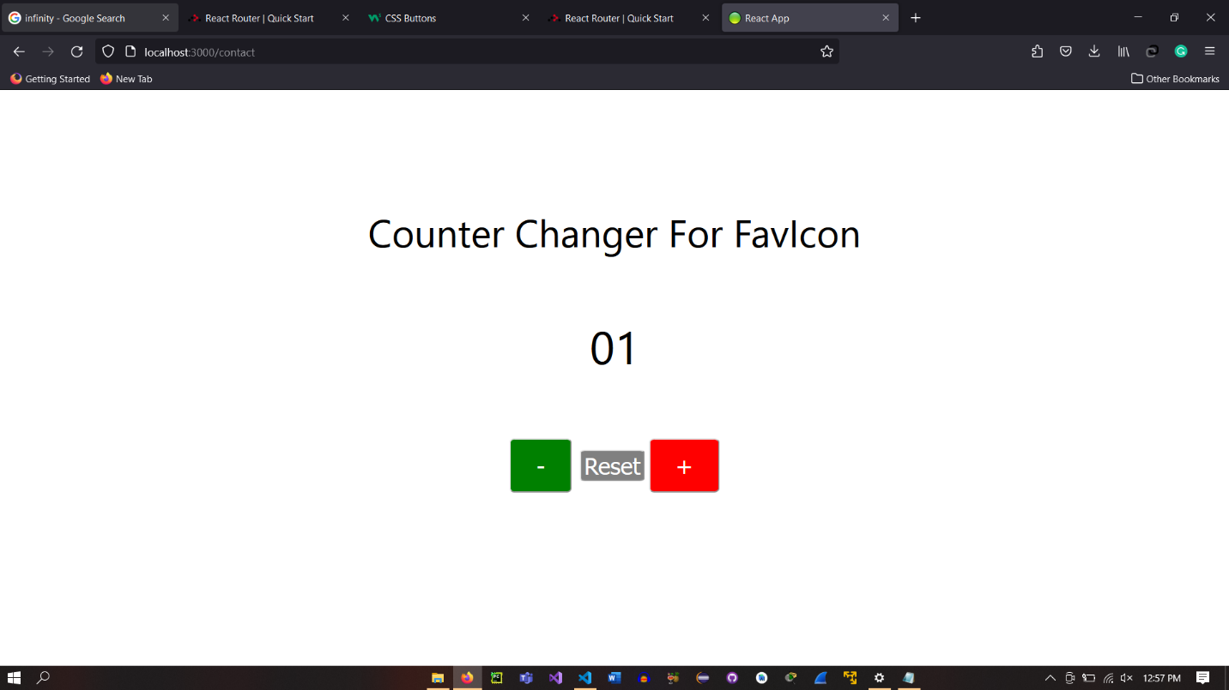

Screenshot of Failed State:

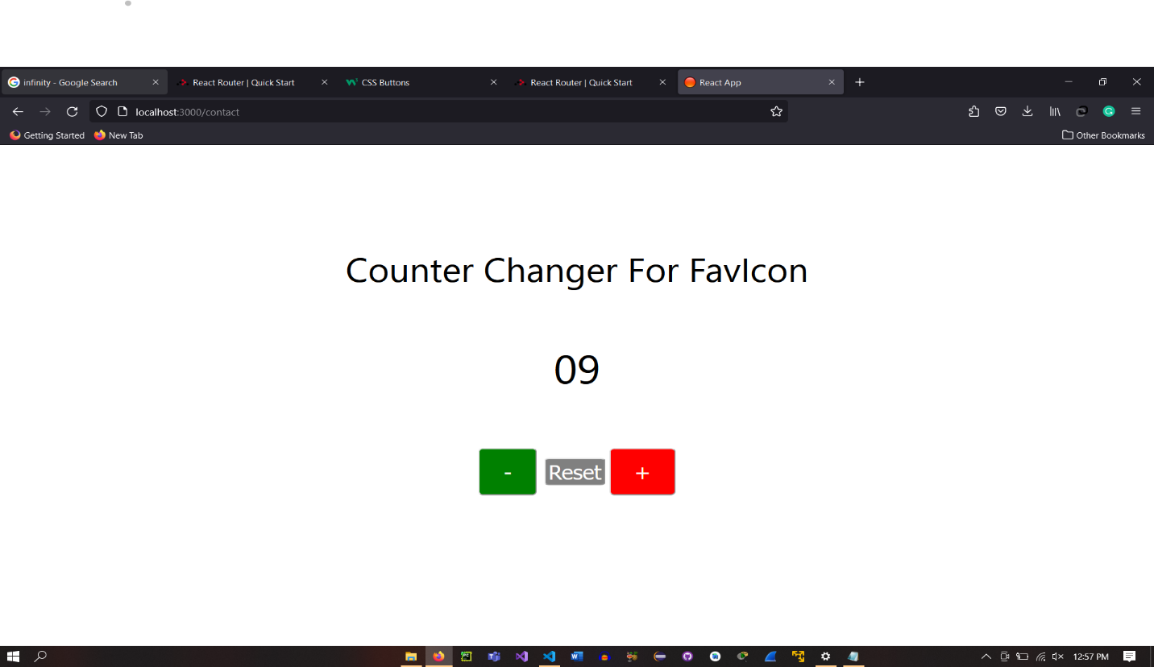

Screenshot of Reset State:

